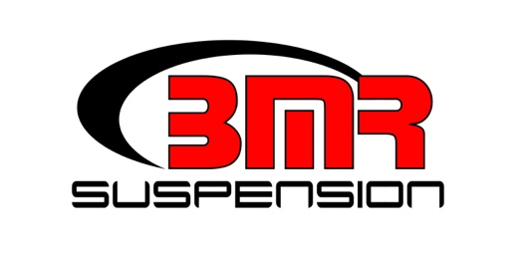

FOR IMMEDIATE RELEASE

**BMR Suspension Front and Rear Sway Bar Kit for 2015 – 2022 Mustang**

**SB763 - $519.95**

Improve handling, reduce body roll, and increase cornering stability on your 2015-2022 Mustang with an adjustable sway bar kit from BMR Suspension. Fabricated from 38mm (front) and 25mm (rear) DOM steel tubing, the BMR sway bars are cold formed to better resist torsional fatigue and retain "memory" far longer than conventional hot-formed bars. The front sway bar bushing brackets are constructed from ¼ steel plate for maximum strength and durability. The BMR Sway Bar Kit (SB763) gives you 157% increase (front) and 208% increase (rear) in sway bar rate over the stock bars, reducing body roll and improving handling. The SB763 features four positions of adjustability on the front sway bar (SB764) and three positions on the rear sway bar. (SB045)

These sway bars mount to the car with 95-durometer polyurethane bushings, greatly reducing deflection compared to rubber bushings. Thrust washers locate the sway bars, eliminating lateral movement under aggressive cornering. BMR has designed the SB763 for street performance, autocross, and road race applications. Front sway bar (SB764) and rear sway bar (SB045) can also be purchased individually. Installation time is 3-4 hours. Available in black hammertone or red powdercoat. Proudly made in America with American steel.

To preview all of BMR’s high-performance suspension parts, please visit [www.bmrsuspension.com](http://www.bmrsuspension.com), email [sales@bmrsuspension.com](mailto:sales@bmrsuspension.com), or contact them at BMR Suspension, 928 Sligh Ave, Seffner, FL 33584, 813-986-9302, Fax: 813-986-8055.